# bronchical syrup (250ml)

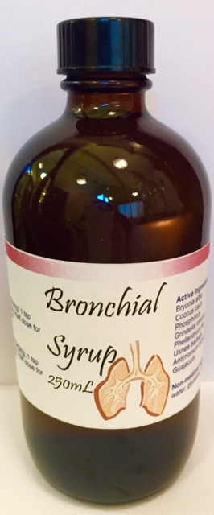

We have made our own version of BRONCHI-PERTU!

**BRONCHIAL**syrup is indicated for bronchitis, asthma, whooping cough and other infections of the breathing passageways. It stimulates excretion of toxins that cause symptoms such as a dry cough with stabbing pains and pus, emphysema and headaches. In addition, this medication functions as a natural plant antimicrobial without the side effects of allopathic equivalents.

**BRONCHIAL**syrup also can help patients who suffer from inherited weakness of the local mucous membranes, such as asthmatics and those prone to severe whooping cough. Practitioners must be aware that continuous bronchial infections indicate a serious ongoing intoxification that requires an exact diagnosis and prompt treatment to prevent the eventual development of asthma.

***Ingredients/Therapeutic Profiles:***

* *Bryonia alba 3X dry cough, stabbing chest pain*
* *Coccus cacti 8X suffocating coughs*
* *Guajacum 3X pus-producing infections*
* *Phellandrium aquaticum 4X bronchitis with dry cough*
* *Phosphorus 6X respiratory infections*
* *Antimonium tartaricum 4X expectorant for all types of coughs*
* *Grindelia robusta 1X excretion of mucus, pertussis*
* *Usnea barbata 1X congestive headaches*